"DEEPGUARD: CONTEXT-AWARE MULTIMODAL
MISINFORMATION DETECTION WITH EXPLAINABLE AI"
Final Year Project Proposal
Bachelor’s of Science in Software Engineering
By

 | Name | Registration # | Mobile # | E-Mail
1 | KHADIJAH IRFAN | SP-23/BSSE/025 | 03260802589 | Khadijahirfan025@gmail.com
2 | ZUJAJAH KHAN | SP-23/BSSE/031 | 03324713700 | zujajah011@gmail.com

Supervised by Co-Supervised by

___________________ ___________________

Mr. Farhan Sarwar Mr. Khaleeq Ahmed


Department of Software Engineering
Lahore Garrison University, Lahore

Table of Contents

Abstract 4
1. Introduction 5
2. Problem Statement 6
2.1 Core Problem 6
2.2 Significance of the Problem 7
2.3 Research Gap 7
2.4 Target Users 7
2.5 Application Scope 7
3. Related Work 8
3.1 Overview 8
3.2 Text-Based Detection Approaches 8
3.3 Image-Based Detection Approaches 9
3.4 Multimodal Detection Approaches 9
3.5 Commercial Solutions 10
4. Project Scope 10
4.1 Project Overview and Goal 10
4.2 Proposed Solution 10
4.3 System Workflow 11
4.4 Value Proposition 11
4.5 How DeepGuard is Different 11
4.6 Final Project Output 11
4.7 Expected Packaging 12
4.8 Hardware and Software Requirements 12
4.9 Datasets 13
4.10 Functional and Non Functional Requirements 13
5. Project Development Methodology 14
5.1 Overview 14
5.2 Justification for Agile 14
5.3 Tools and Technologies 14
5.4 Research Approaches 15
6. Project Milestones and Deliverables 15
6.1 Overview 15
6.2 Project Milestones 16
6.3 Deliverables 16
6.4 Gantt Chart 18
7. Refereneces 18

Abstract
DeepGuard is a multimodal AI-based system designed to detect fake content on social media platforms by analyzing both textual and visual information. The rapid spread of misinformation on platforms such as WhatsApp and Facebook has become a significant global concern, especially in cases where text and images appear individually credible but are misleading when interpreted together. To address this issue, DeepGuard integratss multiple analytical components into a unified framework. It uses a natural language processing model (DistilBERT) to analyze textual content for misleading patterns and a Convolutional Neural Network (CNN) to examine images for potential manipulation or inconsistencies.
In addition, the system incorporates supporting features such as basic metadata analysis, sentiment analysis to detect emotionallly charged language, and identification of common patterns in viral or chain messages. A key feature of DeepGuard is its context consistency checking, which compares information from text and images to identify potential mismatches. The outputs of all components are combined to generate a final prediction along with a confidence score. To enhance transparency, the system provides limited explainibility by highlighting important textual features influencing the result. The system is trained using publicly available datasets such as Fakeddit, FakeNewsNet, and CIFAKE, aiming to deliver a practical and effective solution within an academic project scope.

- Introduction
The rapid growth of social media platforms such as WhatsApp, Facebook, and Twitter has transformed them into major sources of information, but it has also accelerated the spread of misinformation. Fake content often combines text and images in ways that appear credible when viewed separately but become misleading when interpreted together, making detection particularly challenging. Traditional detection approaches typically focus on a single modality, where text-based methods analyze linguistic patterns and image-based systems detect visual manipulation. Even many multimodal approaches process text and images independently and combine their results without exaimining the relationship between them, which limits their ability to identify contextual inconsistencies.
To address these limitations, this project proposes DeepGuard, a multimodal AI-based system that integrates both text and image analysis within a unified framework. The system introduces a crosss-modal consistency checking mechanism that compares information extrected from textual and visual inputs to identify potential mismatches. In addition, it incorporates supporting features such as sentiment analysis to detect emotionally charged language and basic metadata extraction to provide additional context where available.
The scope of this project is focused on developing a web-based application capable of analyzing social media posts consisting of text and images, using practical machine learning and deep learning techniques within an academic setting. The system is designed to remain feasible in terms of development time and resources, while large-scale deployment and real-time integration with social media platforms are not considered within this scope.
The main objective is to design a system that can effectively analyze multimodal content, detect inconsistencies between text and images, and generate a final prediction along with a confidence score. The system also aims to provide a simple and user-friendly interface that allows users to easily input data and understand the results.
To achieve this, the system utilizes a transformer-based model such as DistilBERT for text classification and a Convolutional Neural Network for image analysis. In addition, rule-based techniques are used for sentiment analysis and context consistency checking by comparing keywords extracted from text with labels derived from images. The outputs from all components are then combined to produce a final result that is both accurrate and interpretable.

Problem Statement

Core Problem
In the rapidly evolving digital landscape, the generation of fake visual, audio, and textual content poses a significant threat to the trust of society, political stability, and integrity of information. Social media platforms have become major sources of information for billions of users worldwide. However, they also act as powerful channels for the rapid spread of misinformation. The speed and scale at which fake content propagates make it difficult to control using traditional verification methods. [1]
Existing fake content detection systems primarily focus on analyzing a single modelity either text or image. While these approaches can detect clearly fabricated content, they struggle in more complex real-world scenarios where misinformation is presented through a combination of both text and image.
A key limitation of current systems is their inability to effectively analyze the relationship between text and image. This lead to gaps in detecting the following common scenarios:
Scenario | Description | Detection Status
Scenario 1 | Both text and image are fake | Partially detectable
Scenario 2 | Text is misleading but image is real | Limited detection
Scenario 3 | Image is manipulated but text appears normal | Limited detection
Scenario 4 | Both text and image appear real but contradict each other | Poorly addressed

2.2 Significance of the Problem
The impact of msinformation is widespread and affects multiple aspects of society, including public safety, health, and governance. A large portion of soical media users rely on online platforms for news consumption but lack effective tools to verify content authenticity. In regions like Pakistan, misinformation has contributed to public panic and social unrest, the spread of health-related false information, and misleading political narratives.

2.3 Research Gap
Recent studies in fake content detection highlight several limitations in existing approaches. Most systems rely on unimodal analysis, which is insufficient for real-world multimodal misinformation. Multimodal systems often analyze text and images independently and combine results without deeper interaction. There is also limited focus on context consistency between modelities, along with a lack of interpretable outputs, making it difficult for users to trust system decisions.

2.4 Target Users
DeepGuard is designed for practical use by multiple types of users. General social media users can use it to verify suspicious posts, while journalists and fact-checkers can benefit from faster verification processes. Students and educational institutions can use it to promote digital awareness, and organizations can use it to reduce the risk of sharing unverified content.

2.5 Application Scope
The proposed system can be applied in multiple areas, including social media content verification tools, educational platforms for media literacy, and basic support systems for fact checking workflows.

Related Work

3.1 Overview
Fake content detection has evolved significantly over the past decade, moving from basic keyword-based filtering techniques to advanced machine learning and deep learning approaches. Despite these advancements, several challenges remain unresolved, particularly in analyzing multimodal content and understanding the relationship between text and images.
This section reviews existing approaches in three categories: text based, image based, and multimodal detection systems, along with current commercial tools. Their limitations highlight the need for a more integrated and context-aware solution. [2]

3.2 Text-Based Detection Approaches
Early research in fake content detection primarily focused on textual analysis. Traditional machine learning models such as Support Vector Machines (SVM), Niave Baiyes, and logistic regression were used with handcrafted features like word frequency, sentence structure, and writing style.
More recent approaches utilize deep learning models such as Convolutional Neural Networks (CNNs) and transformer-based models like BERT to capture semantic and contextual information from text.
Approach | Technique | Limitation
Traditional ML Models | SVM, Naive Bayes | Limited feature representation
CNN-based Models | Deep learning on text | Requires large datasets
BERT-based Models | Context-aware NLP | Focuses only on text
Limitation:
Text based systems ignore visual information. They cannot detect misleading content where the image contradicts the text or carries the main deciptive signal.

3.3 Image-Based Detection Approaches
With the rise of image manipulation and deepfake technologies, researchers developed image-based detection systems using computer vision techniques. Convolutional Neural Networks (CNNs) are widely used to detect visual inconsistencies, editing artifacts, or synthetic content.
Approach | Technique | Limitation
CNN based Detection | Image classification | Cannot analyze text context
Deepfake Detection Models | Facial manipulation detection | Limited to specific cases (faces)
GAN Detection Models | Synthetic image detection | Narrow scope
Limitation:
Image based systems operate independently and cannot determine whether an image aligns with the accompanying textual claim. A real image used in a misleading context remains undetected.

3.4 Multimodal Detection Approaches
To overcome unimodal limitations, recent research has introduced multimodal systems that combine text and image analysis. These systems extract features from both modalities and integrate them using fusion techniques.
System | Technique | Limitation
SpotFake | BERT + CNN feature fusion | Limited interaction between modalities
MVAE | Multimodal autoencoder | Lack of interpretability
SAFE | Similarity-based approach | Shallow cross-modal analysis
CLIP-based Models | Joint text-image embeddings | Limited explainability
Limitation:
Although multimodal systems improve performance, most approaches process text and image separately and combine results without deeply analyzing their relationship. They lack effective mechanisms to detect contextual inconsistencies between modelities.

3.5 Commercial Solutions
Several tools are available for fake content verification, but they have practical limitations:
Tool | Functionality | Limitation
Google Fact Check Explorar | Searches verified claims | Requires prior fact-checking
Snopes / AFP Fact Check | Manual verification | Time-consuming and not scalable
Reverse Image Search Tools | Identify image sources | No text analysis
Bot Detection Tools | Analyze user accounts | Do not analyze content
Limitation:
Most commercial tools are either manual, limited to a single modality, or dependent on existing databases. They do not provide automated, real time analysis of combined text and image content.

Project Scope

4.1 Project Overview and Goal
DeepGuard is a multimodal AI-based web application designed to detect fake content on social media by analyzing both text and image inputs. The primarry goal of this project is to improve the detection of misleading posts by combining text analysis, image analysis, and basic cross-modal consistency checking. The system focuses particularly on identifying cases where text and image appear individually credible but may be misleading when interpreted together. In addition to generating a prediction, the system aims to provide basic explanation outputs to help users understand why content is flagged.[3]

4.2 Proposed Solution
DeepGuard will be implemented as a web-based application where users can input suspicious social media content consisiting of text and an image. The system processes the input through multiple analytical components, including a text analysis module that uses a pre-trained NLP model to detect misleading patterns in text and an image analysis module that uses a CNN-based model to classify images as real or potentially manipulated. It also includes supporting features such as basic sentiment analysiss to detect emotionally manipulative language and simple metadata extraction when available. In addition, a context consistency check is performed by comparing key information from text and image labels to identify possible mismatches. The outputs from all these components are combined to generate a final prediction along with a confidence score.

4.3 System Workflow
The system follows a structured workflow where the user first opens the DeepGuard web application and inputs suspicious text along with an uploaded image. The system then processes both inputs through the text and image models. Supporting analyses, including sentiment analysis and metadata extraction, are performed in parallel. After this, the system evaluates the context consistency between the text and image. Finally, a result is generated and displayed to the user.

4.4 Value Proposition
DeepGuard provides value by combining text and image analysis within a single system and introducing context consistency checking between modalities. It generates confidence-based results instead of simple binary outputs and offers basic interpretability by highlighting important textual features influencing the prediction. Additionally, it is designed as a practical and user-friendly web application that can be easily used for verifying suspcious content. [4]

4.5 How DeepGuard is Different
Compared to existing solutions, most systems analyze only one modality, either text or image, while existing multimodal systems often combine outputs without deeper comparison. Many available tools also rely on manual verification or previously verified data. DeepGuard improves upon these approaches by integrating both text and image analysis within a unified system, incorporating a simple cross-modal consistency check, and providing automated and user-friendly analysis for end users.

4.6 Final Project Output
The final deliverable will be a functional web application that includes an input interface built using HTML, CSS, and JavaScript, with a text field for entering social media content, an image upload option supporting JPG and PNG formats, and a button to trigger analysis. The output dashboard will display the final verdict as real or fake along with a confidence score percentage. It will also provide a basic explnation by highlighting important words from the text. Additional outputs may include sentiment indication, such as whether the content is neutral or highly emotional, simple metadata information if available, and a context mismatch alert where applicable.

4.7 Expected Packaging
Component | Description
Deployment Type | Web-based application
Frontend | HTML, CSS, JavaScript
Backend | Python-based processing
Models | Pre-trained and fine-tuned models
Database | Optional (SQLite for storing results)
Hosting | Localhost or Streamlit Cloud
Repository | GitHub with source code and documentation
Documentation | Technical report

4.8 Hardware and Software Requirements

Hardware Requirements

The hardware requirements for DeepGuard include a minimium of 4 to 8 GB of RAM to ensure smooth development and testing of the system. An active internet connection is necessary to access online resources, datasets, and for general development purposes. For model training, a GPU is required, which can be conveniently accessed through platforms such as Google Colab to accelerate the training of deep learning models.

Software Components
Category | Technology
Programming Language | Python
NLP Model | HuggingFace Transformers (DistilBERT)
Image Processing | OpenCV / Pillow
Deep Learning | PyTorch
Web Framework | Streamlit
Database | SQLite
Version Control | GitHub

4.9 Datasets
The datasets used in this project include FakeEddit, which is a multimodal dataset combining text and images, FakeNewsNet, which focuses on textual fake news detection, and CIFAKE, which contains real versus AI-generated images. This project contributes to existing work by exploring multimodal fake content detection in a practical setting, introducing context-aware analysis that evaluates the relationship between text and image, and providing a simple yet interpretable system designed to be suitable for real-world usage
4.10 Functional and Non Functional Requirements:
DeepGuard is designed to fulfill several functional requirements. It allows users to input social media content consisting of text and an image, which the system analyzes using integrated text and image models. The system performs sentiment analysis and metadata extraction when available, and checks for consistency between text and image content. It generates a prediction indicating whether the content is likely real or fake, along with a confidence score. Additionally, the system provides basic explanations by highlighting key textual features and optionally indicates sentiment or metadata information to improve user understanding.
In terms of non-functional requirements, DeepGuard is designed to be a responsive and user-friendly web application, ensuring quick processing and minimal latency for moderate-sized inputs. The system is scalable to handle multiple concurrent users in a local or small network deployment and is built with maintainable code using Python for backend logic and HTML, CSS, and JavaScript for the frontend interface. Security and data privacy are considered for any optional stored results, and the application is compatible with standard web browsers to maximize accessibility. [5]

Project Development Methodology

5.1 Overview
DeepGuard will be developed using an Agile development methodology, which supports iterative development, continuous testing, and gradual system enhancement. This approach is suitable because the project consists of multiple components (text analysis, image analysis, and supporting features) that can be developed and tested independently before integration.
Agile allows early development of a working prototype, followed by incremental improvements, reducing risk and ensuring steady progress throughout the project.

5.2 Justification for Agile
Methodology | Suitability | Reason
Agile | Most Suitable | Supports incremenatal development and continuous testing
Waterfall | Not Suitable | Rigid structure, difficult to adapt if issues arise
Spiral | Partially Suitable | Complex for small academic projects
Prototyping | Partially Suitable | Useful for UI but not full system development

5.3 Tools and Technologies
Category | Technology | Purpose
Programming Language | Python | Core development
NLP | HuggingFace Transformers | Text analysis
Deep Learning | PyTorch | Model training
Image Processing | OpenCV / Pillow | Image handling
Web Interface | Streamlit | Frontend
Backend Logic | Python | Processing pipeline
Database | SQLite | Store results
Version Control | GitHub | Code management
Development Platform | Google Colab | Model training

5.4 Research Approaches
To ensure effectiveness, alternative approaches will be explored for key components. For text analysis, a traditional machine learning approach using TF-IDF features combined with an SVM model will serve as a baseline, while a transformer-based model, specifically DistilBERT, is expected to deliver better performance due to its contextual understanding of language. For image analysis, a basic CNN model will be implemented as a baseline, while transfer learning using MobileNetV2 is expected to improve accuracy and reduce training time significantly. For combining outputs from multiple modules, both simple averaging of module scores and weighted scoring, if feasible, will be considered to determine the most reliable method for generating the final prediction.

Project Milestones and Deliverables

6.1 Overview
The development of DeepGuard is planned over a period of six months, with clearly defined milestones and deliverables for each phase. Each milestone represents a measurable checkpoint to track progress and ensure timily completion of the project.
An Agile-based approach will be followed, allowing incremental development, testing, and integration of system components. This reduces risk and ensures that a working prototype is available early in the development cycle.

6.2 Project Milestones
Milestone | Description | Timeline | Success Criteria
M1 Foundation Setup | Environment setup, dataset selection, literature review | Month 1 | Tools configured, datasets selected, initial understanding established
M2 Basic Features | Implementation of sentiment analysis and metadata extraction | Month 2 | Features working on sample inputs
M3 Core Models | Development of text and image analysis models | Month 3–4 | Models trained and producing reasonable predictions
M4 Context Module | Implementation of context consistency checking | Month 4 | Basic mismatch detection working
M5 System Integration | Integration into web application | Month 5 | End-to-end system functional
M6 Finalization | Testing, documentation, and preparation for defense | Month 6 | System tested and ready for submission

6.3 Deliverables
Milestone 1: Foundation Setup focuses on establishing the groundwork for the DeepGuard project. This includes preparing a literature review document summarizing relevant research, setting up the complete development environment, collecting and preprocessing datasets required for model training, and creating the initial system design represented through an archetecture diagram.
Milestone 2: Basic Features involves the implementation of foundational modules. This includes developing a basic sentiment analysis module to detect emotionally charged language, a metadata extraction module if available, and preparing an initial user interface to allow basic input and output interactions with the system.
Milestone 3: Core Models centers on the training and evaluation of the main analytical components. This includes developing a trained text classification model and a trained image classification model, accompanied by detailed training notebooks and evaluation results that document model performance.
Milestone 4: Context Module addresses the implementation of cross-modal analysis. It involves creating the context consistency checking logic and preparing test cases that demonstrate the system’s ability to detect mismatches between text and image content effectively.
Milestone 5: System Integration covers the combination of all developed components into a cohesive system. This milestone includes integrating backend processing modules, developing a fully functional web application using standard web technologies, and ensuring that the system provides combined outputs, including a final verdict and confidence score for user submissions.
Milestone 6: Finalization completes the project with comprehensive testing and documentation. Deliverables include a final test report assessing system performance, the complete FYP documentation in the required formet, presentation slides for defense, and the organized source code repository on GitHub containing all project files.

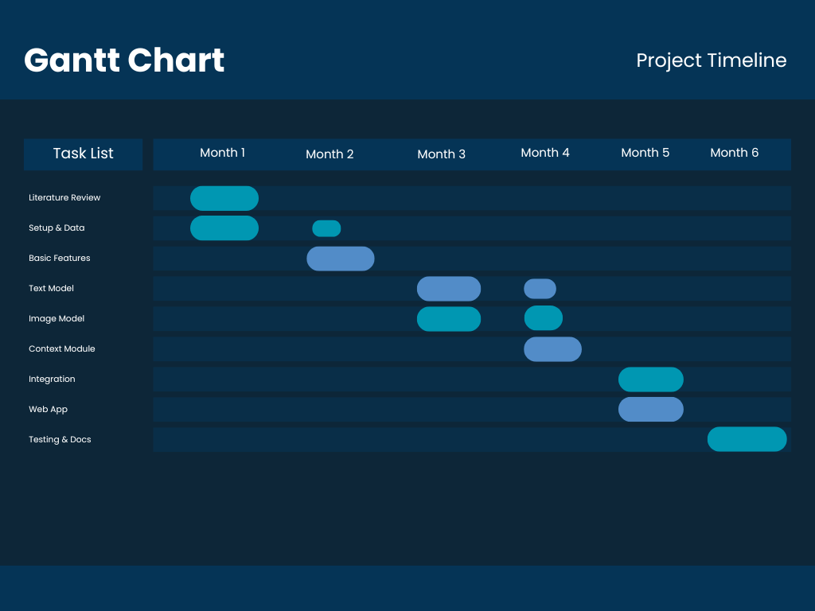
6.4 Gantt Chart

Research Papers Supporting Our Work:
- SpotFake, IEEE 2019: Published multimodal fake detection system using BERT and VGG19 achieving 85-90% accuracy. DeepGuard builds on this foundation adding metadata analysis, sentiment manipulation detection, viral pattern detection, and explainable AI which SpotFake completely lacks.
- Systematic Review of 121 Studies, ScienceDirect 2024: Identified context mismatch detection and explainable AI as the two most critical research gaps in current fake detection systems. DeepGuard directly addresses both gaps simultaneously.
- Multimodal Fusion Survey, Springer 2025: Confirmed that multimodal systems analyzing both text and image achieve 85-90% accuracy compared to 63-72% for single modality systems. This validates our multimodal approach.
- References
[1] Mirsky Y, Lee W. The creation and detection of deepfakes: A survey. ACM computing surveys (CSUR). 2021 Jan 2;54(1):1-41.
[2] Gambín ÁF, Yazidi A, Vasilakos A, Haugerud H, Djenouri Y. Deepfakes: current and future trends. Artificial Intelligence Review. 2024 Feb 19;57(3):64.
[3] Shahzad HF, Rustam F, Flores ES, Luis Vidal Mazon J, De la Torre Diez I, Ashraf I. A review of image processing techniques for deepfakes. Sensors. 2022 Jun 16;22(12):4556.
[4] Van der Nagel E. Verifying images: Deepfakes, control, and consent. Porn Studies. 2020 Oct 1;7(4):424-9.
[5] Firc A, Malinka K. The dawn of a text-dependent society: deepfakes as a threat to speech verification systems. InProceedings of the 37th ACM/SIGAPP symposium on applied computing 2022 Apr 25 (pp. 1646-1655).

